Load Balancers Task

>>Launch EC2 Instances
Purpose: Create backend servers to receive traffic from the Load Balancers.
Step 1: Launch Instance 1
- Open AWS Console.
- Go to EC2.
- Click Launch Instance.
- Name: Web-Server-1
- AMI: Amazon Linux 2023
- Instance Type: t3.micro
- Select/Create a Key Pair.
- Select your VPC.
- Select Public Subnet 1.
- Enable Auto-assign Public IP.
- Create or select a Security Group:
  - SSH (22) → Your IP
  - HTTP (80) → Anywhere
  - HTTPS (443) → Anywhere
- Launch the instance.

Step 2: Launch Instance 2
- Click Launch Instance.
- Name: Web-Server-2
- Select the same AMI.
- Select the same Instance Type.
- Select the same Key Pair.
- Select the same VPC.
- Select Public Subnet 2 (different Availability Zone).
- Enable Public IP.
- Attach the same Security Group.
- Launch.

>> Install Apache on Both Instances
Purpose: Host a web application.
Connect to Instance
ssh -i key.pem ec2-user@<Public-IP>
Install Apache
sudo dnf update -y
sudo dnf install httpd -y
sudo systemctl enable httpd
sudo systemctl start httpd
Create Test Page
Instance 1
echo "<h1>Web Server 1</h1>" | sudo tee /var/www/html/index.html
Instance 2
echo "<h1>Web Server 2</h1>" | sudo tee /var/www/html/index.html
Verify:
http://Public-IP

Task 1: Configure Classic Load Balancer
Purpose: Distribute HTTP traffic.
Steps
- EC2 → Load Balancers.
- Create Load Balancer.
- Select Classic Load Balancer.
- Name it.
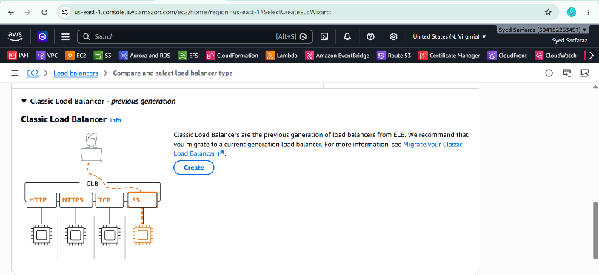
- Internet-facing.
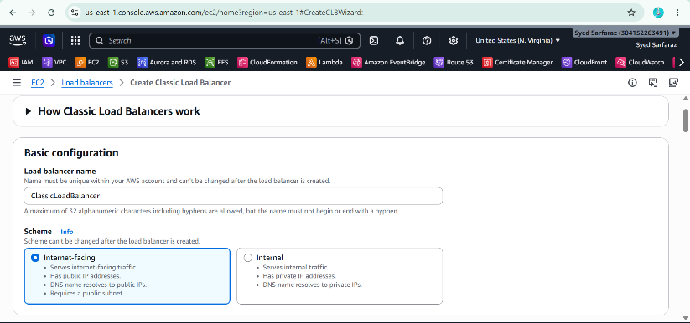
- Select your VPC.
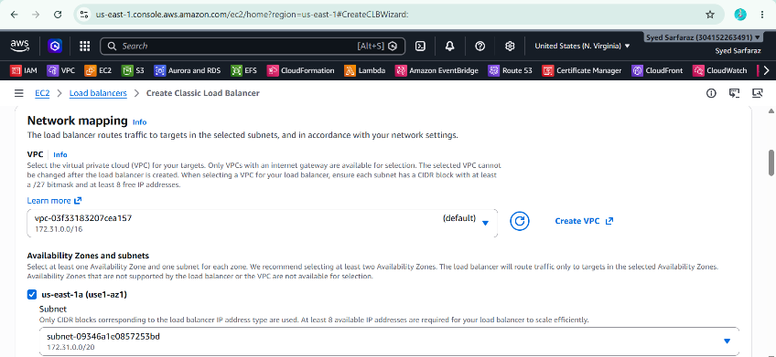
- Select Public Subnet 1 and Public Subnet 2.
- Listener:
  - HTTP
  - Port 80
- Select Security Group.
- Health Check:
  - HTTP
  - Port 80
  - Path /
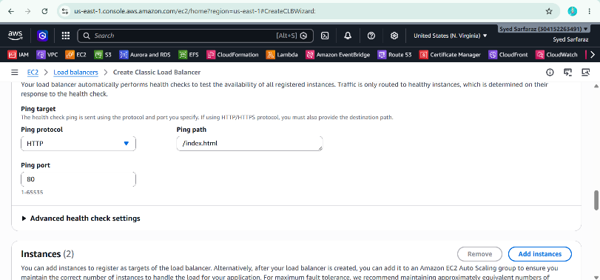
- Register both EC2 instances.
- Create.
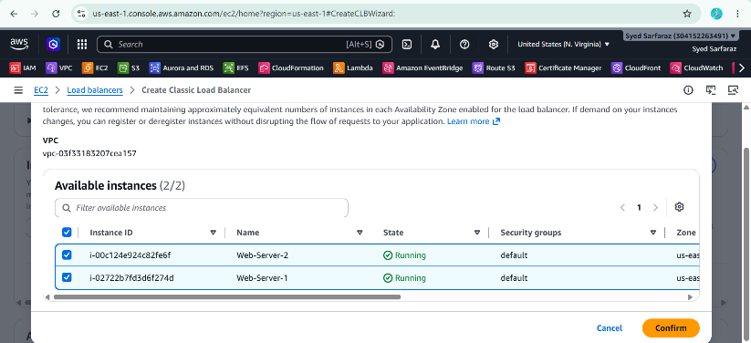
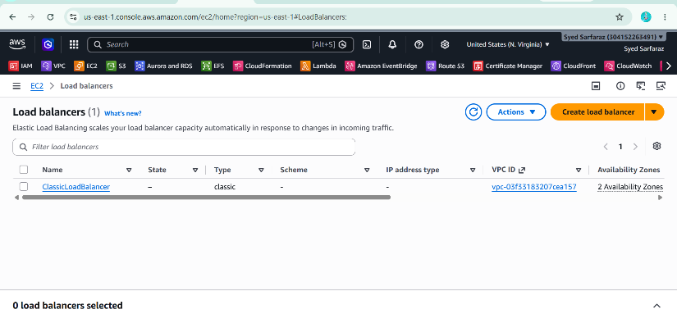
- Test using CLB DNS Name.

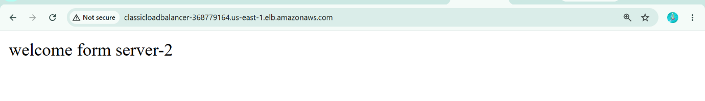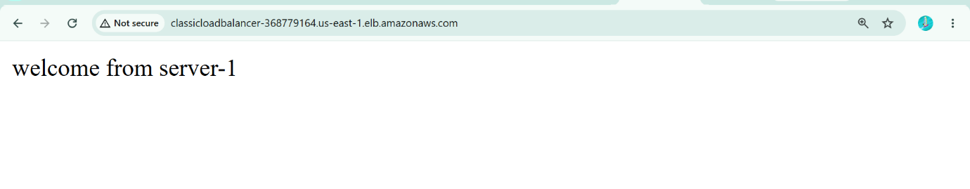

Task 2: Configure Application Load Balancer
Purpose: Route HTTP/HTTPS traffic.
Create Target Group
- EC2 → Target Groups.
- Create Target Group.
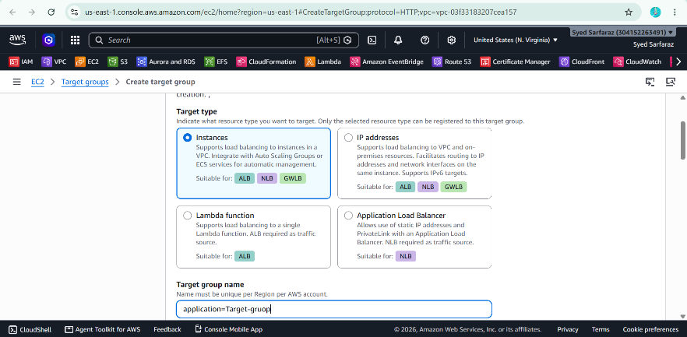
- Target Type → Instances.
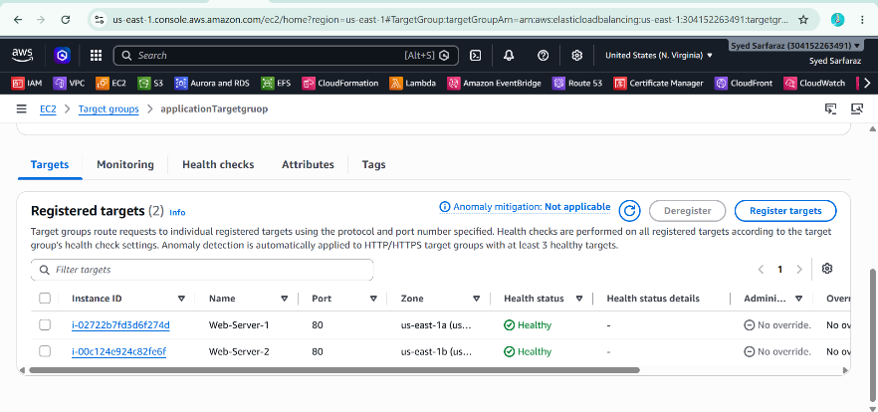
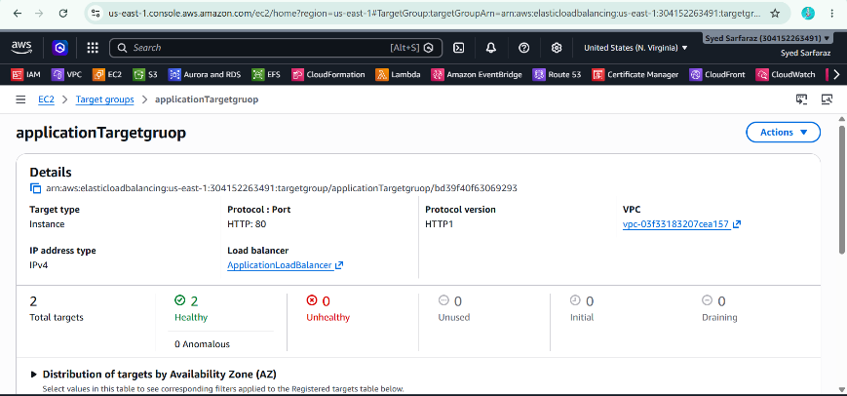
- Protocol → HTTP.
- Port → 80.
- Select VPC.
- Register both instances.
- Create.
Create ALB
- EC2 → Load Balancers.
- Create → Application Load Balancer.
- Name.
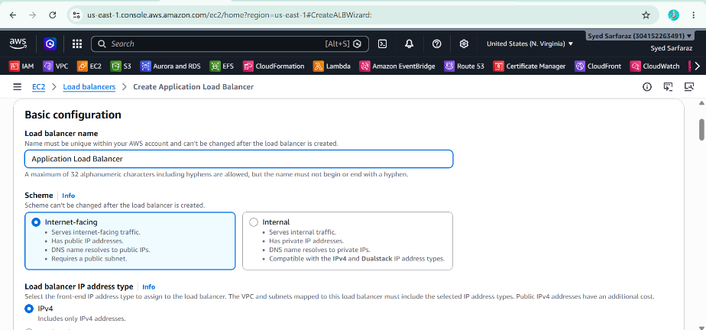
- Internet-facing.
- IPv4.
- Select VPC.
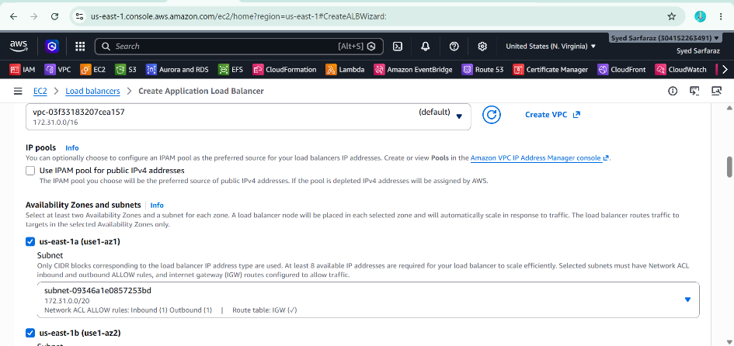
- Select both Public Subnets.
- Select Security Group.
- Listener:
  - HTTP
  - Port 80
- Forward to Target Group.
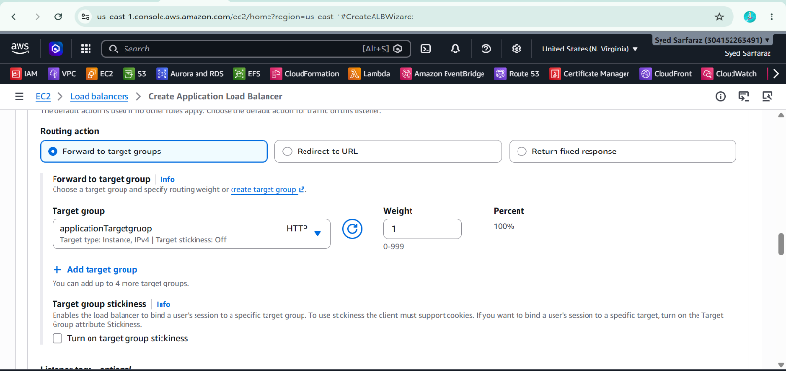
- Create.
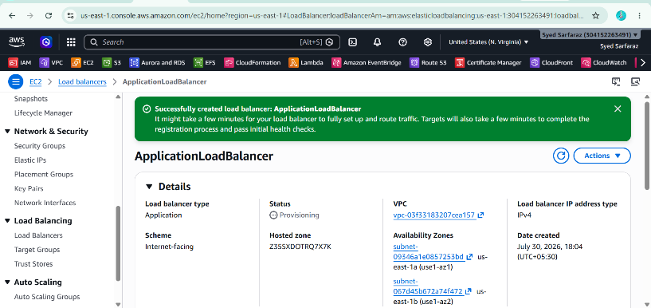

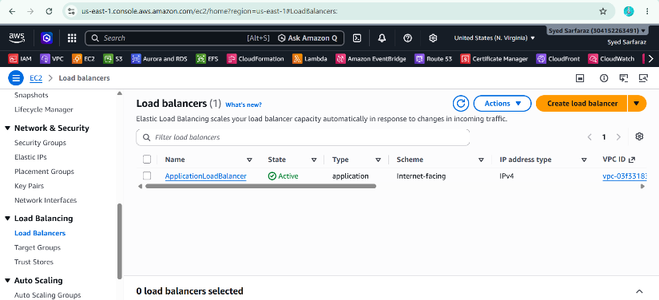
- Test using ALB DNS.
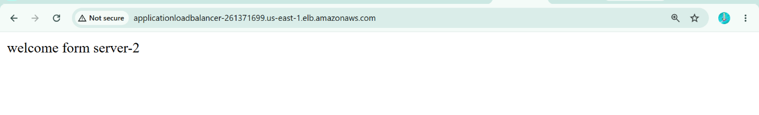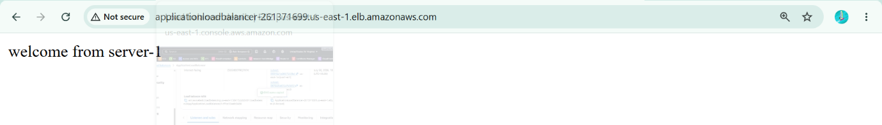

Task 3: Configure Network Load Balancer
Purpose: Handle TCP traffic.
Create Target Group
- Create Target Group.
- Protocol → TCP.
- Port → 80.
- Register both EC2 instances.
- Create.
Create NLB
- Create Load Balancer.
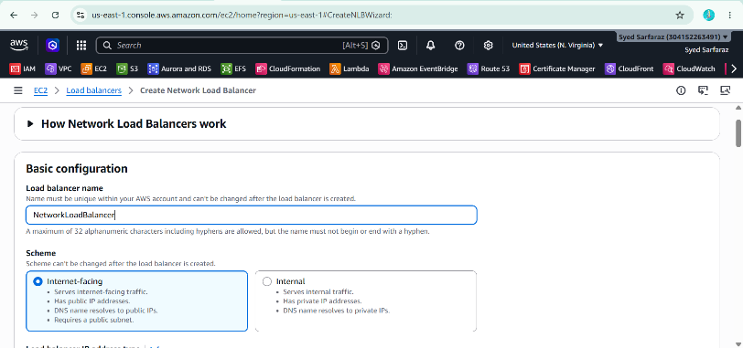
- Select Network Load Balancer.
- Internet-facing.
- Select VPC.
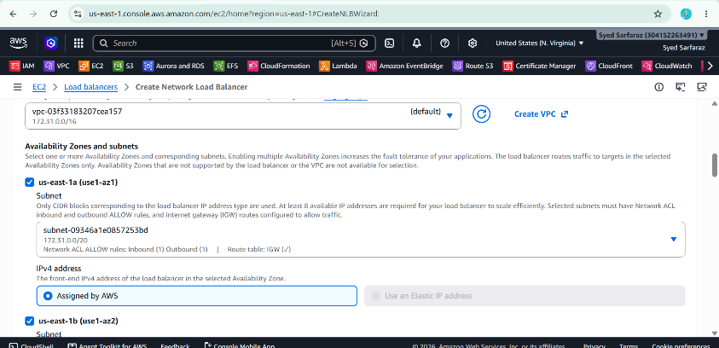
- Select Public Subnets.
- Listener:
  - TCP
  - Port 80
- Select Target Group.

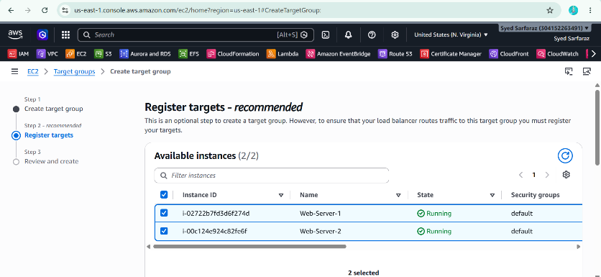
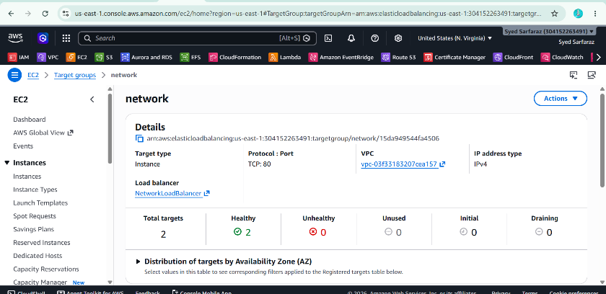
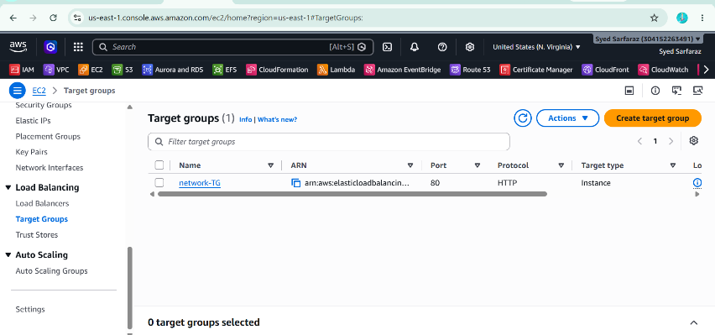
- Create.
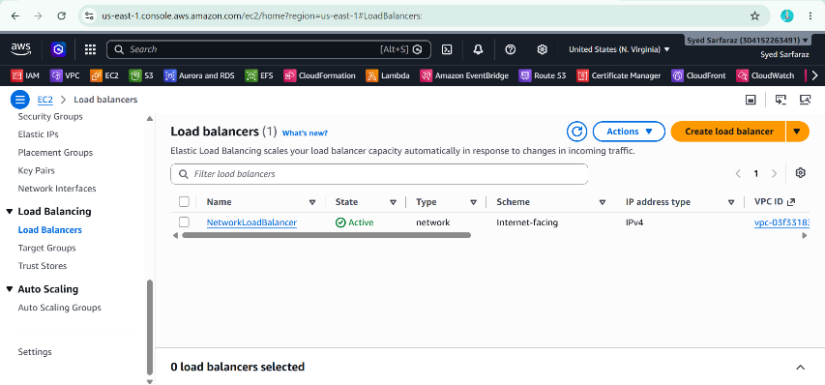
- Test using NLB DNS.
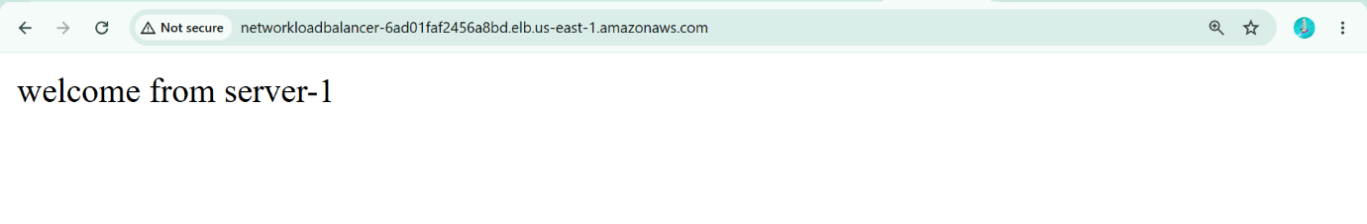
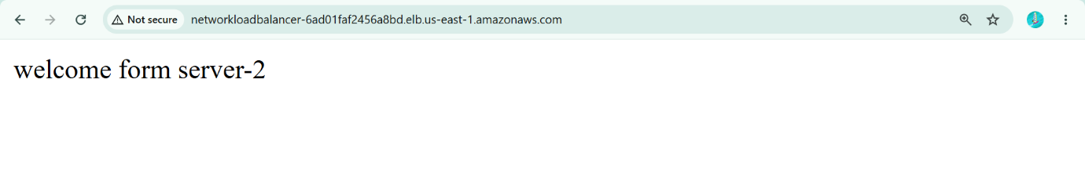

Task 4: Create an ACM Certificate
Step 1
- Open AWS Certificate Manager (ACM).
- Ensure the region is the same as your ALB (for example, us-east-1).
- Click Request.
- Select Request a public certificate.
- Click Next.
Step 2
Add these domain names:
sarfaraztech.site
Validation Method
DNS Validation
Click Request.
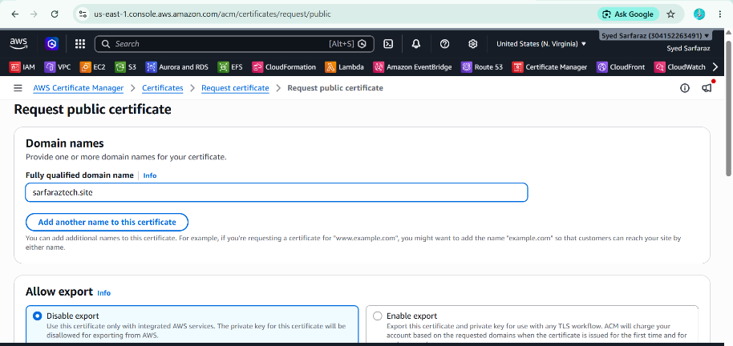

Task 5: Create a Route 53 Hosted Zone
Step 1
- Open Route 53.
- Click Hosted Zones.
- Click Create Hosted Zone.
Fill in:
Field | Value
Domain Name | sarfaraztech.site
Type | Public Hosted Zone
Click
Create Hosted Zone
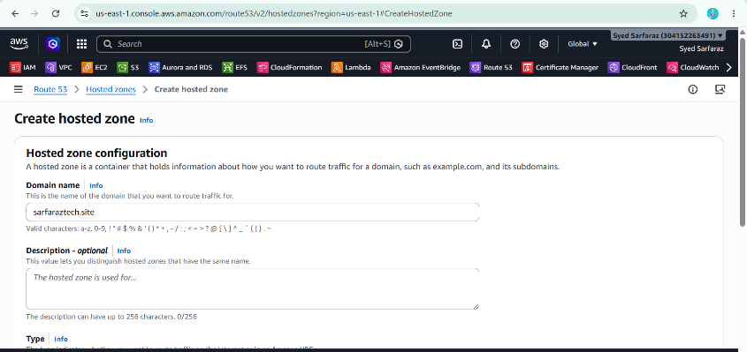

Step 2: Change GoDaddy Name Servers
After the Hosted Zone is created:
- Open the Hosted Zone.
- Copy the 4 NS (Name Server) values.
Example:
ns-123.awsdns-12.com
ns-456.awsdns-34.net
ns-789.awsdns-56.org
ns-987.awsdns-78.co.uk
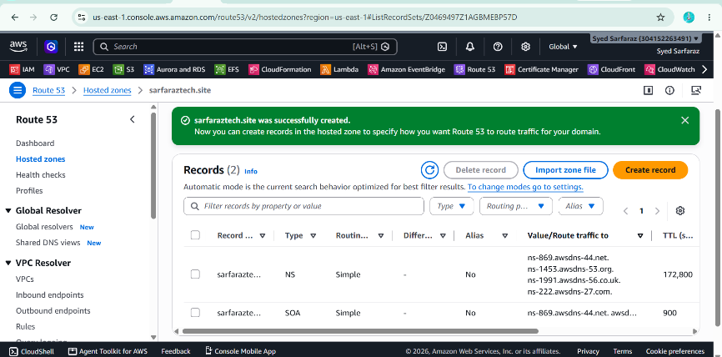

Go to GoDaddy
- My Products
- Click DNS
- Click Nameservers
- Choose
Change
Select
I'll use my own nameservers
Paste all 4 Route 53 name servers.
Save.
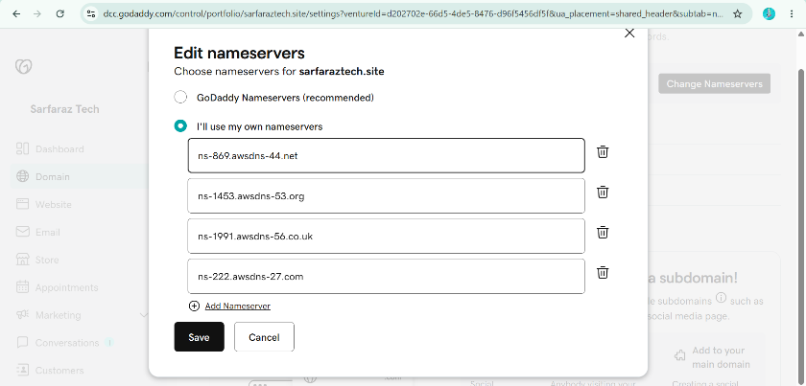
Wait for DNS propagation. This usually takes 15 minutes to a few hours, but can take up to 48 hours.

Step 3: Validate the ACM Certificate
After the Route 53 hosted zone is active:
- Open AWS Certificate Manager.
- Open your certificate.
- Click
Create records in Route 53
AWS automatically creates the required CNAME validation record in Route 53.
Wait until the certificate status changes to:
Issued

Step 4: Attach the SSL Certificate to the ALB
- Open EC2 → Load Balancers.
- Select your Application Load Balancer.
- Open Listeners and rules.
Add HTTPS Listener
Protocol
HTTPS
Port
443
Certificate
Select from ACM
Choose your Issued certificate.
Default Action
Forward to your Target Group
Click
Add listener
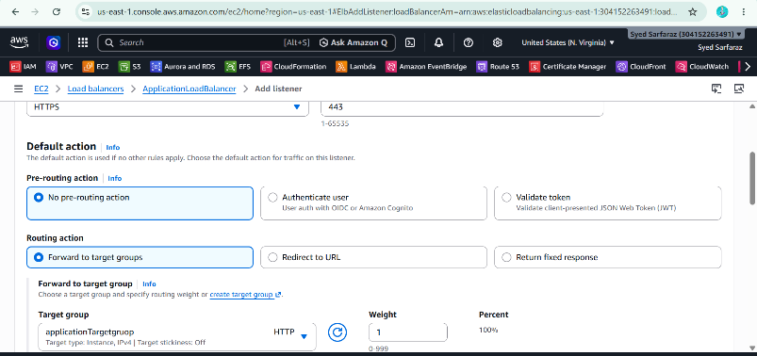
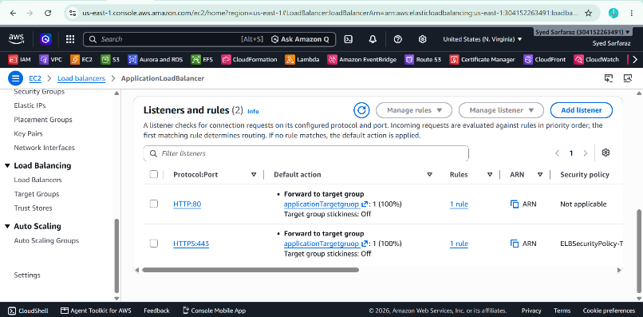

Step 5: Redirect HTTP to HTTPS
- Select the HTTP : 80 listener.
- Click Edit listener.
Change the default action to:
Redirect to
Configure:
Field | Value
Protocol | HTTPS
Port | 443
Status Code | HTTP_301
Save.
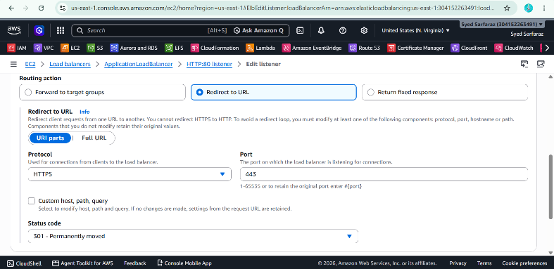

Step 6:Create an Alias Record in Route 53
Open
Route 53 → Hosted Zone → sarfaraztech.site
Click
Create Record
Configure:
Field | Value
Record Name | (Leave blank)
Record Type | A
Alias | Yes
Route Traffic To | Alias to Application and Classic Load Balancer
Region | us-east-1
Load Balancer | Select your ALB
Click
Create Records
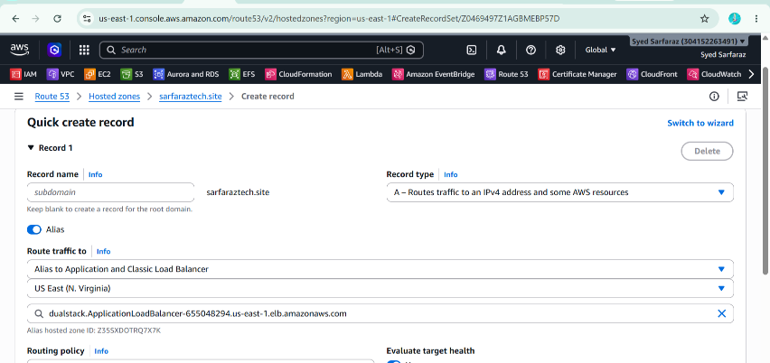

Step 7: Create the www Record
Click
Create Record
Configure:
Field | Value
Record Name | www
Record Type | A
Alias | Yes
Route Traffic To | Alias to Application and Classic Load Balancer
Region | us-east-1
Load Balancer | Select your ALB
Click
Create Records
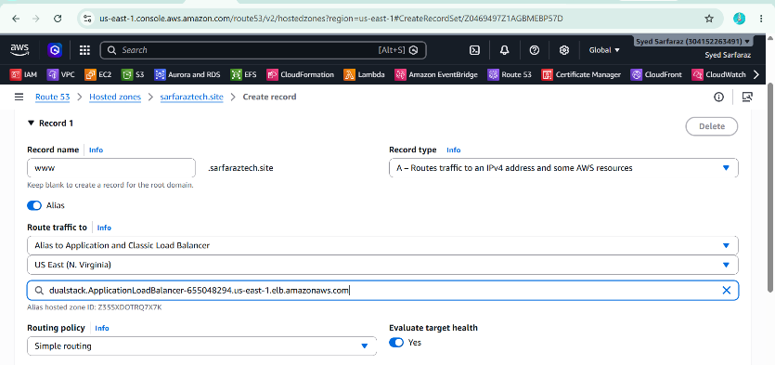

Step 8: Test using Sarfaraztech.site DNS Name.
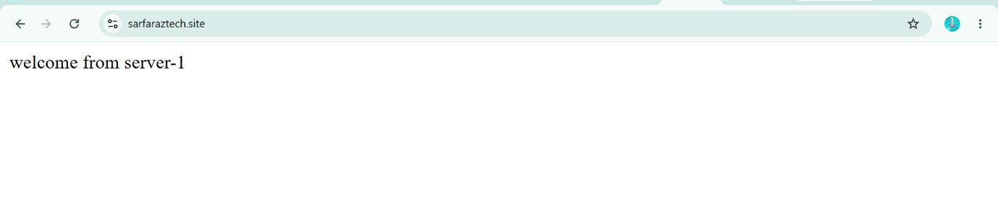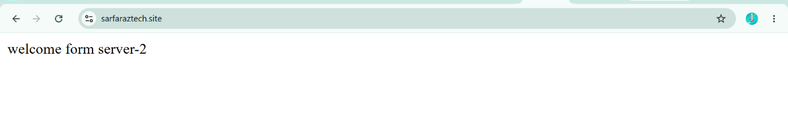

Final Architecture
GoDaddy (Domain Registration)
│
▼
Route 53 (Hosted Zone + DNS)
│
▼
Alias Record
│
▼
Application Load Balancer
│
▼
Target Group
│
┌──┴────┐
▼ ▼
EC2-1 EC2-2

Task 6: Push the Application Load Balancer Logs to S3
Step 1: Create an S3 Bucket
- Open AWS Console.
- Go to S3.
- Click Create bucket.
Fill in:
Field | Value
Bucket name | sarfaraztech-alb-logs (must be globally unique)
AWS Region | Same region as your ALB (e.g., us-east-1)
Block Public Access | Leave enabled (default)
Click Create bucket.
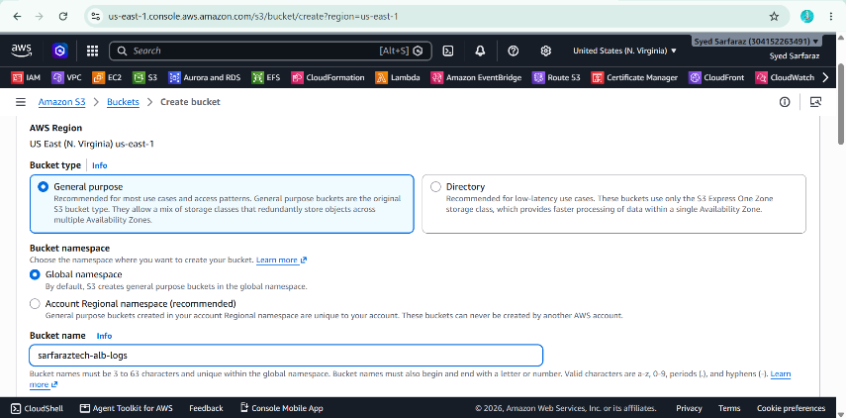

Step 2: Copy Your AWS Account ID
Go to:
AWS Console → Top Right → Account ID
Example:
304152263491
Use your own account ID.

Step 3: Add Bucket Policy
- Open the S3 bucket.
- Go to the Permissions tab.
- Scroll to Bucket Policy.
- Click Edit.
- Paste the following policy.
(using your account ID 304152263491):

{
"Version": "2012-10-17",
"Statement": [
{
"Sid": "AWSLogDeliveryWrite",
"Effect": "Allow",
"Principal": {
"Service": "logdelivery.elasticloadbalancing.amazonaws.com"
},
"Action": "s3:PutObject",
"Resource": "arn:aws:s3:::sarfaraztech-alb-logs/AWSLogs/304152263491/*"
},
{
"Sid": "AWSLogDeliveryAclCheck",
"Effect": "Allow",
"Principal": {
"Service": "logdelivery.elasticloadbalancing.amazonaws.com"
},
"Action": "s3:GetBucketAcl",
"Resource": "arn:aws:s3:::sarfaraztech-alb-logs"
}
]
}
Click Save changes.
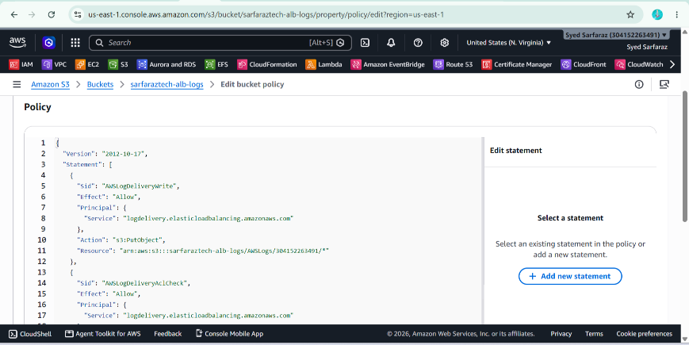

Step 4: Enable Access Logs on the ALB
- Go to EC2.
- Click Load Balancers.
- Select your Application Load Balancer.
- Open the Attributes tab.
- Click Edit.
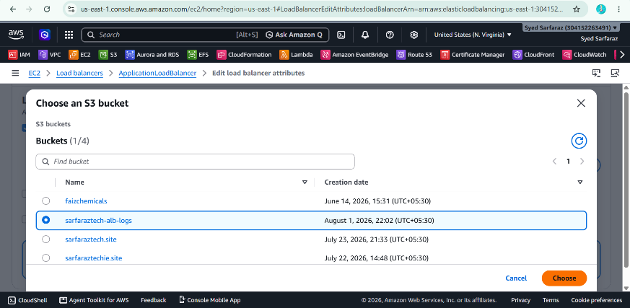

Step 5: Configure Access Logs
Enable:
- Access logs: ✅ Enable
- S3 bucket: Select or enter your bucket name (e.g., sarfaraztech-alb-logs)
- Prefix (optional): alb-logs
Click Save changes.
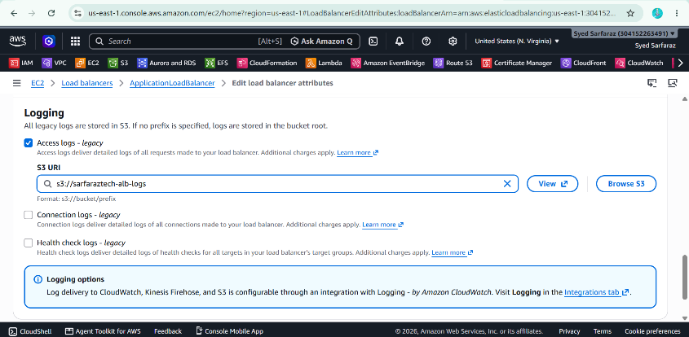

Step 6: Generate Traffic
Open your website several times, for example:
- http://sarfaraztech.site
- https://sarfaraztech.site
- https://www.sarfaraztech.site
Refresh the pages 10–20 times to generate log entries.

Step 7: Verify Logs
- Go to S3.
- Open your bucket.
- Navigate to:
AWSLogs/
└── 304152263491/
└── elasticloadbalancing/
└── us-east-1/
